1. Peiyun Zeng

Before defining a constructor Cannot use a unnilialzied variable 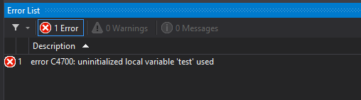

After defining a default constructor using initializer list, we are able to print out the member variables

1. After changing it to class, we cannot cout the member varaibles.

This is because, struct will have member variables public by default while class will have them public by default

4.

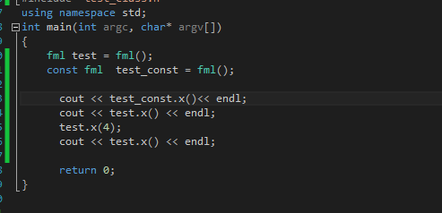

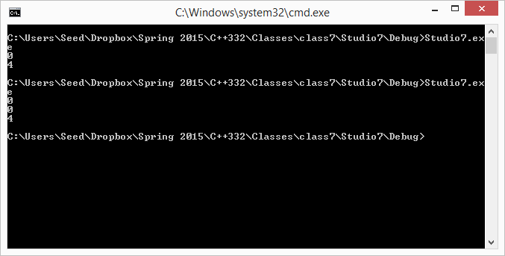

Qeustion

1. M.x(7).y(3) does not work
2. The default constructor copy the member functions while the custom one only take the reference

